KIDS’ ZONE
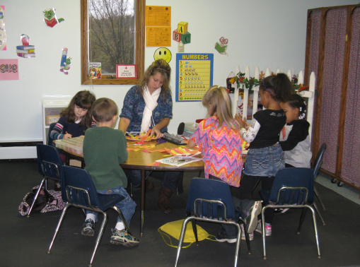
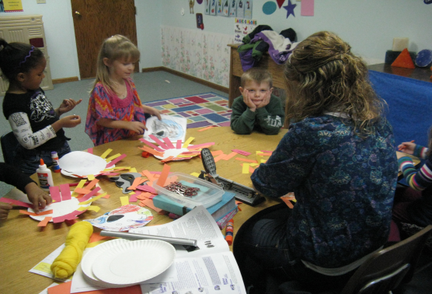

Woodville GBC has the same heart for children that Jesus has. We want to be a place where kids can come and learn practical life lessons from the Bible and understand that they matter to God. Each week the kids are challenged in different ways to see how God’s Word can shape their lives to help them become moral and upstanding citizens.
They are encouraged to:
- Have fun
- Try hard
- Be honest
- Be the best God made them to be

